Hotel Management System

# A Project Report

Submitted in partial fulfillment of the Requirements for the award of the Degree of

BACHELOR OF SCIENCE (INFORMATION TECHNOLOGY)

RITIK VISHWAKARMA

Seat Number: 19TIT159

Under the Esteemed Guidance of Mrs. Sumathi Rajkumar

Professor



**DEPARTMENT OF INFORMATION TECHNOLOGY NIRMALA MEMORIAL FOUNDATION COLLEGE OF COMMERCE & SCIENCE**

***(Affiliated to University of Mumbai)* MUMBAI-400101 MAHARASHTRA**

# 2021-22



CERTIFICATE

This is to certify that the project entitled, **HOTEL MANAGEMENT SYSTEM** is bonafied work of **RITIK VISHWAKARMA bearing** Seat. No: **19TIT159** submitted in partial fulfillment of the requirement for the award of degree of BACHELOR OF SCIENCE in INFORMATION TECHNOLOGY from University of Mumbai.

PROF. VAISHALI MISHRA

Internal Examiner Coordinator

External Examiner

Date: College Seal

# PROFORMA FOR THE APPROVAL PROJECT PROPOSAL

PNR NO.: **…………………** Roll no:

1. Name of the Student

# RITIK VISHWAKARMA

1. Title of the Project

# HOTEL MANAGEMENT SYSTEM

1. Name of the Guide

# PROF. SUMATHI RAJKUMAR

1. Teaching experience of the Guide

# 10 YEARS

1. Is this your first submission?

**Yes** No

Signature of the Student Signature of the Guide

Date: **……………** Date: **……………**

Signature of the Coordinator Date: ……………………

ACKNOWLEDGEMET

We would like to express our special thanks of gratitude to our professor **MRS. SUMATHI RAJKUMAR** as well as our principal **MS. SWIDDLE D’CUNHA** who gave me this wonderful opportunity to do this project on the topic **HOTEL MANAGEMENT SYSTEM**

, which also helped me in doing a lot of research and I came to know about so many new things, I am really thankful to them.

Secondly, I would like to thank my parents and friends who helped me a lot in finalizing this project in the limited time frame.

**RITIK VISHWAKARMA**

DECLARATION

I / We hereby declare that the project entitled, “**HOTEL MANAGEMENT SYSTEM**” done at **NIRMALA MEMORIAL FOUNDATION**

COLLEGE, has not been in any case duplicated to submit to any other university for the award of any degree. To the best of my knowledge other than me, no one has submitted to any other university. The project is done in partial fulfillment of the requirement for the award of degree of BACHELOR OF SCIENCE (INFORMATION TECHNOLOGY) to be submitted as final semester project as part of our curriculum.

**RITIK VISHWAKARMA**

**Table of Contents**

|  |  |  |
| --- | --- | --- |
| Sr.  No. | Particular | Page No. |
| 1 | CHAPTER 1: INTRODUCTION | 8 |
| 1.1 | Background | 8 |
| 1.2 | Objectives | 8 |
| 1.3 | Purpose, Scope and Applicability | 9 |
| 1.3.1 | Purpose | 9 |
| 1.3.2 | Scope | 9 |
| 1.3.3 | Applicability | 9 |
|  | Achievement | 10 |
| 1.5 | Organization Report | 10 |
| 2 | CHAPTER 2: SURVEY OF TECHNOLOGIES | 11 |
| 3 | CHAPTER 3: REQUIREMENTS AND ANALYSIS | 14 |
| 3.1 | Problem Definition | 14 |
| 3.2 | Requirements Specification | 14 |
| 3.3 | Planning Scheduling | 14 |
|  | Software and Hardware Requirements | 14 |
| 3.5 | Preliminary Product Description | 15 |
| 3.6 | Conceptual Models | 15 |
| 4 | CHAPTER 4: SYSTEM DESIGN | 16 |
| 4.1 | Basic Modules | 16 |
| 4.2 | Data Design | 17 |
| 4.2.2 | Data Integrity and Constraints | 17 |
| 4.3 | Procedural Design | 18 |
| 4.3. I | Data Structures | 18 |
| 4.3.2 | Algorithms Design | 19 |
| 5 | CHAPTER 5: IMPLEMENTATION AND TESTING | 20 |
| 5.1 | Implementation Approaches | 20 |

|  |  |  |
| --- | --- | --- |
| 5.3 | Testing Approach | 21 |
| 5.3.1 | Unit Testing | 21 |
| 5.3.2 | Integrated Testing | 22 |
| 5.3.3 | Beta Testing | 23 |
| 5.4 | Test Cases | 24 |
| 6 | CHAPTER 6: RESULTS AND DISCUSSION | 25 |
| 6.1 | Test Reports | 26 |
| 6.2 | User Documentation | 27 |
| 7 | CHAPTER 7: CONCLUSIONS | 28 |
| 7.1 | Conclusion | 28 |
| 7.3 | Future Scope of the Project | 28 |
| 8 | CHAPTER 8:REFERENCES | 29 |
|  |  | 31 |

# Chapter-1

* 1. BACKGROUND

The project, Hotel Management System is a web-based application that allows the hotel manager to handle all hotel activities online. Interactive GUI and the ability to manage hotel bookings and rooms make this system very flexible and convenient. The hotel manager is a very busy person and does not have the time to sit and manage the entire activities manually on paper. This application gives him the power and flexibility to manage the entire system from a single online system. Hotel management project provides room booking, staff management and other necessary hotel management features. The system allows the manager to post available rooms in the system. Customers can view and book room online. Admin has the power of either approving or disapproving the customer’s booking request. Other hotel services can also be viewed by the customers and can book them too. The system is hence useful for both customers and managers to portable manage the hotel activities.

* 1. OBJECTIVES
* Manage reservations
* Safe and secure payment gateway module
* Save time spent by standing in queue for purchase of your booking
* Pay online using online payment facility Generate detailed report of sale details
* Manage various trips, rates and types
* Allow users to book room online
* easy checkin and checkout
* Get clear view of our hotel and make your choice more clear.
  + 1. PURPOSE

The hotel management system provides the quality service to the end user. This project aims at creating on Hotel Management System which can be used by Admin and Customers. The admin to advise/publish the availability of rooms in different hotels and customers are checking the availability of room. Customers should be able to know the availability of the rooms on a particular date to reserve in hotel. They should be able to reserve the available rooms according to their need in advance. To make their stay comfortable. The Admin hands the booking information of customers. The users can register and log into the system. The administrator will know the details of reservation.

* + 1. SCOPE

Our project aims at Business process automation, i.e. I have tried to computerize various processes of Hotel Management System.

It may help collecting perfect management in details. In a very short time, the collection will be obvious, simple and sensible. It will help a person to know the management. It also helps in current all works. It will be also reduced the cost of collecting the management & collection procedure will go on smoothly.

* The system generates types of information that can be uses for various purposes.

1. It satisfy the user requirement
2. Be easy to understand by the user and operator
3. Be easy to operate.
4. Have a good user interface
   * 1. APPLICABILITY

Easy management and administration of a hotel with capabilities of:

* Booking
* Reservations of the rooms
* Cancellation of the rooms
* Room service
* Restaurant service & billing & Total billing
* Travels arrangement etc

One can keep detailed records or info on an unlimited number of customers. The system lets the user know which all rooms are available for occupancy at any point of time. This makes the booking considerably faster. And thus, helps the hotel in better management and reduce a lot of paper work as well as manpower.

# Chapter-2

1. PROGRAMMING LANGUAGE
   1. **HTML**

Hypertext Markup Language (HTML) is the standard markup language for documents designed to be displayed in a web browser. It can be assisted by technologies such as Cascading Style Sheets (CSS) and scripting languages such as JavaScript. Web browsers receive HTML documents from a web server or from local storage and render the documents into multimedia web pages. HTML describes the structure of a web page semantically and originally included cues for the appearance of the document.

HTML elements are the building blocks of HTML pages. With HTML constructs, images and other objects such as interactive forms may be embedded into the rendered page. HTML provides a means to create structured documents by denoting structural semantics for text such as headings, paragraphs, lists, links, quotes and other items. HTML elements are delineated by tags, written using angle brackets. Tags such as <img/> and <input/> directly introduce content into the page. Other tags such as <p> surround and provide information about document text and may include other tags as sub-elements. Browsers do not display the HTML tags, but use them to interpret the content of the page.

HTML can embed programs written in a scripting language such as JavaScript, which affects the behaviour and content of web pages. Inclusion of CSS defines the look and layout of content. The World Wide Web Consortium (W3C), former maintainer of the HTML and current maintainer of the CSS standards, has encouraged the use of CSS over explicit presentational HTML since 1997.

* 1. CSS

Cascading Style Sheets (CSS) is a style sheet language used for describing the presentation of a document written in a markup language like HTML.CSS is a cornerstone technology of the World Wide Web, alongside HTML and JavaScript.CSS is designed to enable the separation of presentation and content, including layout, colours, and fonts. This separation can improve content accessibility, provide more flexibility and control in the specification of presentation characteristics, enable multiple web pages to share formatting by specifying the

relevant CSS in a separate .css file, and reduce complexity and repetition in the structural content.

CSS information can be provided from various sources. These sources can be the web browser, the user and the author. The information from the author can be further classified into inline, media type, importance, selector specificity, rule order, inheritance and property definition. CSS style information can be in a separate document or it can be embedded into an HTML document. Multiple style sheets can be imported. Different styles can be applied depending on the output device being used; for example, the screen version can be quite different from the printed version, so that authors can tailor the presentation appropriately for each medium. The style sheet with the highest priority controls the content display. Declarations not set in the highest priority source are passed on to a source of lower priority, such as the user agent style. The process is called cascading.

One of the goals of CSS is to allow users greater control over presentation. Someone who finds red italic headings difficult to read may apply a different style sheet. Depending on the browser and the web site, a user may choose from various style sheets provided by the designers, or may remove all added styles and view the site using the browser's default styling, or may override just the red italic heading style without altering other attributes.

* 1. JAVASCRIPT

JavaScript s a high-level, interpreted scripting language that conforms to the ECMAScript specification. JavaScript has curly-bracket syntax, dynamic typing, prototype-based object-orientation, and first-class functions. Alongside HTML and CSS, JavaScript is one of the core technologies of the World Wide Web. JavaScript enables interactive web pages and is an essential part of web applications. The vast majority of websites use it,and major web browsers have a dedicated JavaScript engine to execute it. As a multi-paradigm language, JavaScript supports event- driven, functional, and imperative (including object-oriented and prototype-based) programming styles. It has APIs for working with text, arrays, dates, regular expressions, and the DOM, but the language itself does not include any I/O, such as networking, storage, or graphics facilities. It relies upon the host environment in which it is embedded to provide these features.

Initially only implemented client-side in web browsers, JavaScript engines are now embedded in many other types of host software, including server-side in web servers and databases, and in non-web programs such as word processors and PDF software, and in runtime environments that make JavaScript available for writing mobile and desktop applications, including desktop widgets.

The terms Vanilla JavaScript and Vanilla JS refer to JavaScript not extended by any frameworks or additional libraries. Scripts written in Vanilla JS are plain JavaScript code. Google's Chrome extensions, Opera's extensions, Apple's Safari 5 extensions, Apple's Dashboard Widgets, Microsoft's Gadgets, Yahoo! Widgets, Google Desktop Gadgets are implemented using JavaScript.

CHAPTER - 3

**3.1. Problem Definition :**

The theme of my project is Hotel Management System. The main aim of this project is gives

customer view of hotel. This system is made in such a way that a minimum educated and simple

computer knowledge person can use this system without any option of error. There are basically

two types of user who can use this system one is online users who are the customers who can see

the hotel updates and can book rooms and second one is administrator who is responsible for

updating the hotel details on system.

Modules

Number of Modules:

* Accommodation Information Module
* Units Information Module.
* Bookings Information Module.
* Guests Information Module.

ACCOMMODATION INFORMATION:

This module maintains all the details of the Accommodation that are available.

UNITS INFORMATION:

This module maintains the information regarding all the units that are registered as per specifications and their reference unit types. The module also takes care of the system from the unit facilities and reference unit facilities that are available

BOOKING MODULE:

This module maintains the information of all the booking of the units, as pet the guest requirements.

GUEST MODULE:

This module maintains the overall activities through which a guest is uniquely registered is the domain the module interpreter with the specific gender status.

* 1. **Requirements Specification**

Hardware-configuration:

Computer processor : Intel Pentium Dual core Hard-disk : 50 GB (min)

Ram : 512 MB (min)more

System-Type : 64 bit operating system

Processor : X64-based Processor

Graphics : Intel UHD Graphic

Mouse : USB mouse

Software-configuration:

Operating system : Windows 10

Language used : HTML, CSS, PHP

Data Base : MySQL

* 1. Planning and Scheduling

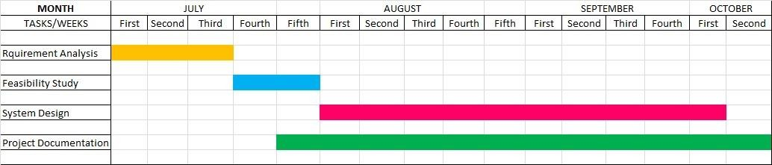

CHAPTER – 4

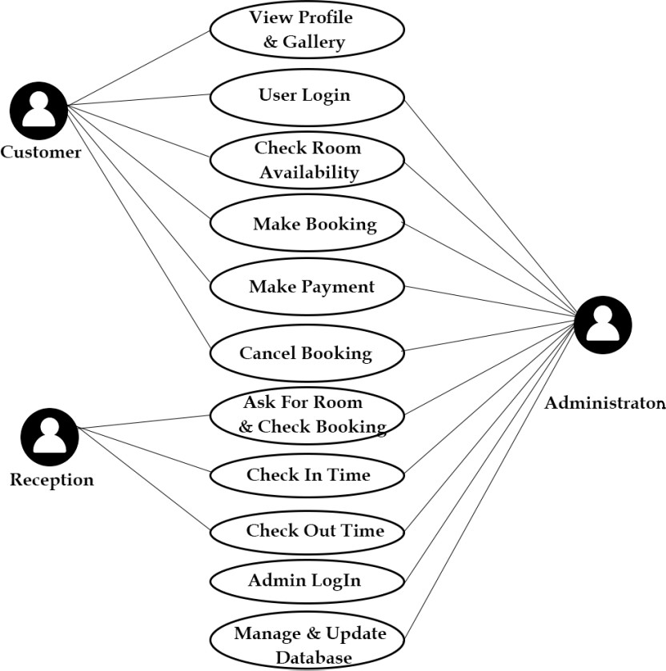

* + 1. Basic Modules (USE-CASE DIAGRAM)

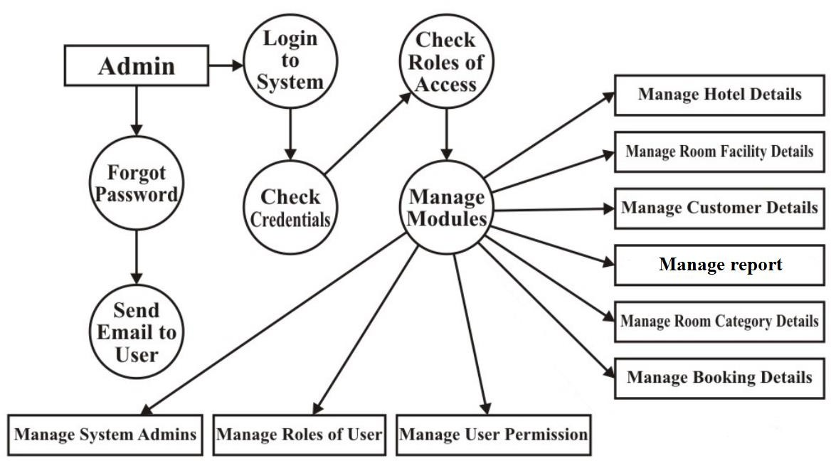

* + 1. - Data Flow diagrams

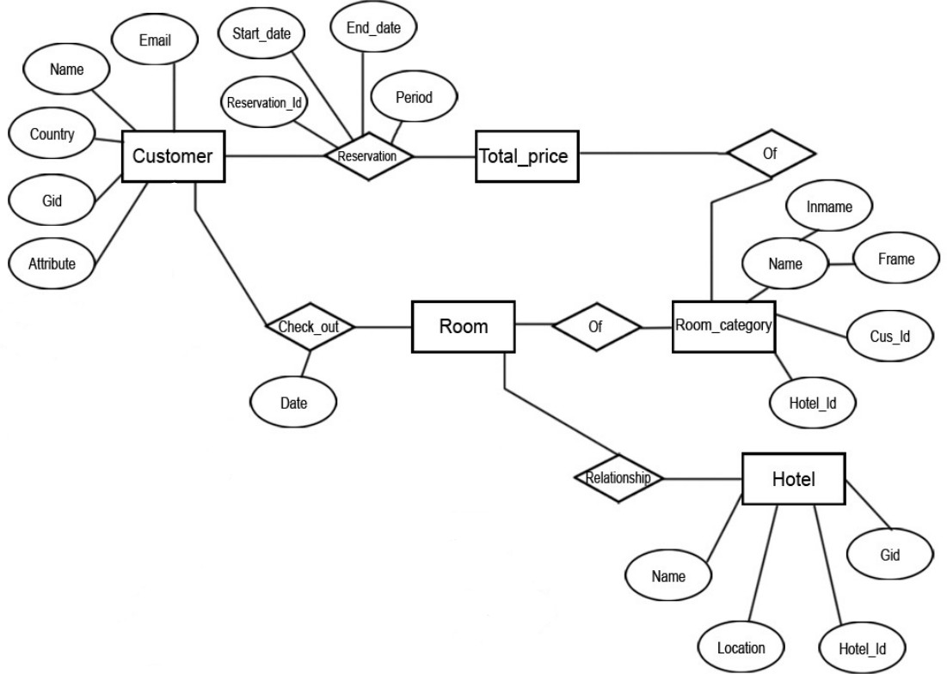

4.2 - Data Design (ER - DIAGRAM)

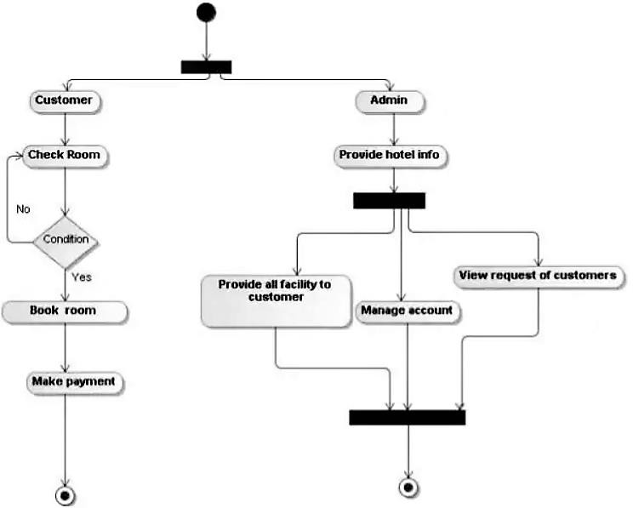

4.3.1 Logic Diagrams (ACTIVITY DIAGRAM)

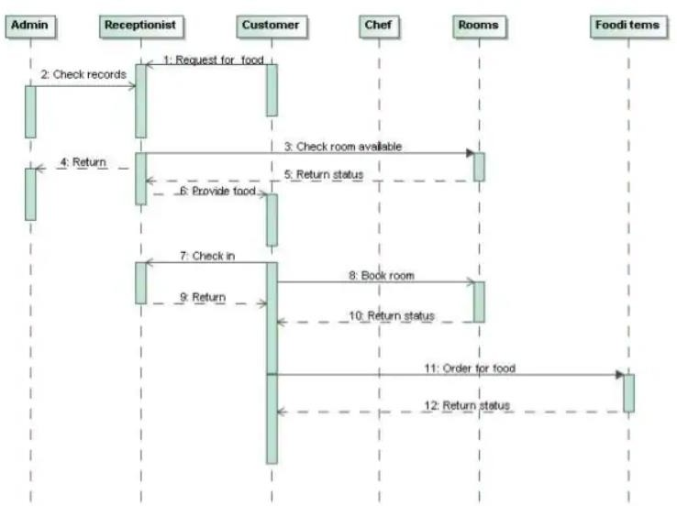

4.3.1 Logic Diagrams (SEQUENCE DIAGRAM)

**CHAPTER 5**

**IMPLEMENTATION AND TESTING**

**5.1 Implementation Approaches :**

The term implementation has different meanings ranging from the conversation of a basic application to a complete replacement of a computer system. The procedures however, are virtually the same. Implementation includes all those activities that take place to convert from old system to new. The new system may be totally new replacing an existing manual or automated system or it may be major modification to an existing system. The method of implementation and time scale to be adopted is found out initially. Proper implementation is essential to provide a reliable system to meet organization requirement

**5.2  Coding Details and Code Efficiency**

**5.2.1 Code Details**

**LOGIN PAGE**

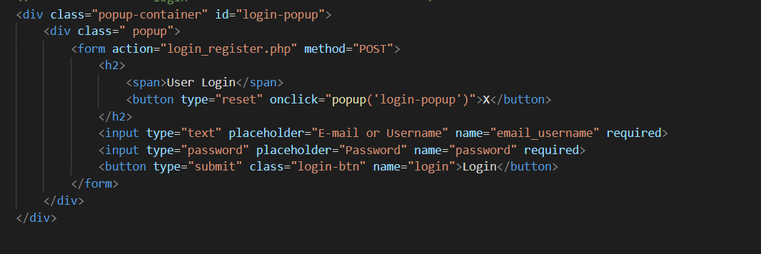

**PROFILE PAGE**

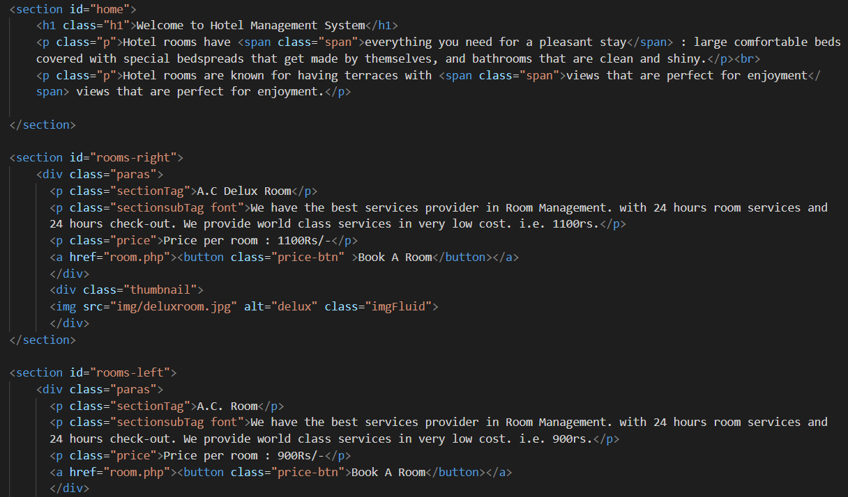

**5.2.2 Code Efficiency**   
**LOC metrics**

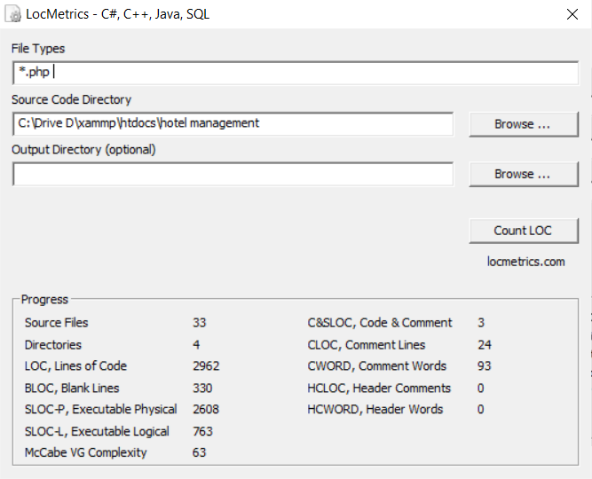

**5.3 Testing Approach**

A design methodology combines a systematic set of rules for creating a program design with diagramming tools needed to represent it. Procedural design is best used to model programs that have an obvious flow of data from input to output. It represents the architecture of a program as a set of interacting processes that pass data from one to another.

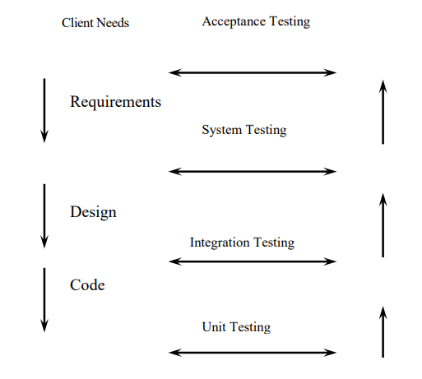

**5.3.1 Unit Testing:**

Unit testing is a level of software testing where individual units/ components of a software are tested. The purpose is to validate that each unit of the software performs as designed. A unit is the smallest testable part of any software. It usually has one or a few inputs and usually a single output.

**5.3.2 Integrated Testing**

Integration Testing is defined as a type of testing where software modules are integrated logically and tested as a group. A typical software project consists of multiple software modules, coded by different programmers. Integration Testing focuses on checking data communication amongst these modules.

**5.3.3 Beta Testing**

Beta Testing is one of the Acceptance Testing types, which adds value to the product as the end-user (intended real user) validates the product for functionality, usability, reliability, and compatibility. Beta testing adds value to the software development life cycle as it allows the "real" customer an opportunity to provide inputs into the design, functionality, and usability of a product. These inputs are not only critical to the success of the product but also an investment into future products when the gathered data is managed effectively

**5.4 Test Cases**

Test Cases: 1

Identifier: T1 Purpose: Test functionality of login form.

Pre-requisite: Appropriate database with sample record should be ready.

Test Input/data:

User login:

|  |  |  |  |  |
| --- | --- | --- | --- | --- |
| Test case ID | Description | Expected Result | Actual Result | Remark |
| TC1 | Username:ritik  Password:ritik | Login | Successful | Pass |

**User Registration:**

|  |  |  |  |  |
| --- | --- | --- | --- | --- |
| Test case ID | Description | Expected Result | Actual Result | Remark |
| TC1 | Name:Ritik  Username:ritik  Password : ritik  E-Mail: [Ritikv37@gmail.com](mailto:Ritikv37@gmail.com) | Registration Successful | Successful | Pass | |
| TC2 | Name:hello  Username:hello  Password : hello  E-Mail: [hello@gmail.com](mailto:hello@gmail.com) | Registration Successful | Successful | Pass | |
| TC3 | Name:abc  Username:abc  Password : abc  E-Mail: [abc@gmail.com](mailto:Ritikv37@gmail.com) | Registration Successful | Successful | Pass | |

**5.5 Security Issues**

▪ SQL Injections: -

SQL injection is a type of web application security vulnerability in which an attacker attempts to use application code to access or corrupt database content. If successful, this allows the attacker to create, read, update, alter, or delete data stored in the back-end database. SQL injection is one of the most prevalent types of web application security vulnerabilities.

▪ Cross Site Scripting (XSS): -

Cross-site scripting (XSS) targets an application's users by injecting code, usually a client-side script such as JavaScript, into a web application's output. The concept of XSS is to manipulate client-side scripts of a web application to execute in the manner desired by the attacker. XSS allows attackers to execute scripts in the victim's browser which can hijack user sessions, deface websites or redirect the user to malicious sites.

▪ Broken Authentication and Session Management: -

Broken authentication and session management encompass several security issues, all of them having to do with maintaining the identity of a user. If authentication credentials and session identifiers are not protected at all times, an attacker can hijack an active session and assume the identity of a user.

▪ Insecure Direct Object References: -

Insecure direct object reference is when a web application exposes a reference to an internal implementation object. Internal implementation objects include files, database records, directories and database keys. When an application exposes a reference to one of these objects in a URL, hackers can manipulate it to gain access to a user's personal data.

▪ Security Misconfiguration: -

Security misconfiguration encompasses several types of vulnerabilities all centered on a lack of maintenance or a lack of attention to the web application configuration. A secure configuration must be defined and deployed for the application, frameworks, application server, web server, database server and platform. Security misconfiguration gives hackers access to private data or features and can result in a complete system compromise

**CHAPTER 6**

**RESULTS AND DISCUSSIONS**

6.1 Test Reports

**BVA**

Boundary Value Analysis (BVA) is a black box test design technique based on test cases. This technique is applied to see if there are any bugs at the boundary of the input domain. Thus, with this method, there is no need of looking for these errors at the center of this input.

BVA helps in testing the value of boundary between both valid and invalid boundary partitions. With this technique, the boundary values are tested by the creation of test cases for a particular input field.

Login side:

Mobile no:

|  |
| --- |
|  |

Please enter valid no:

|  |  |  |
| --- | --- | --- |
| Invalid (min-1) | Valid(only 10 digit) | Invalid(max+1) |
| **345** | **8080007255** | **80800072555** |

**6.2 User Documentation**

**Home Page:**

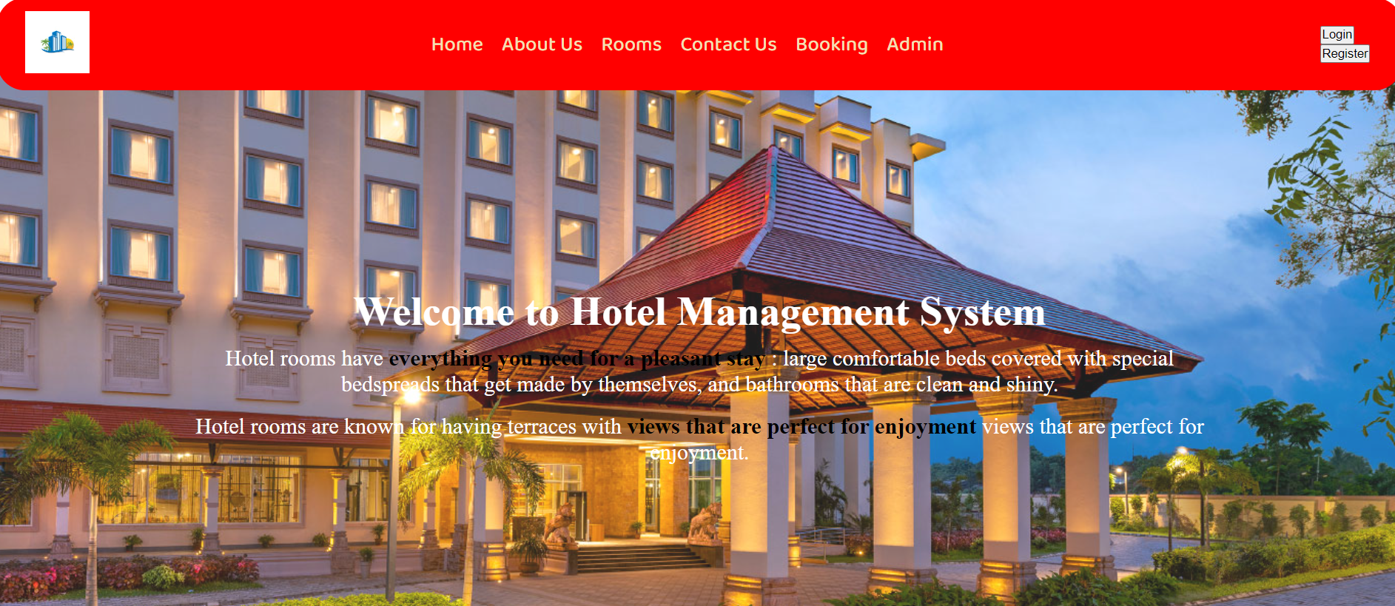

**Login Popup:**

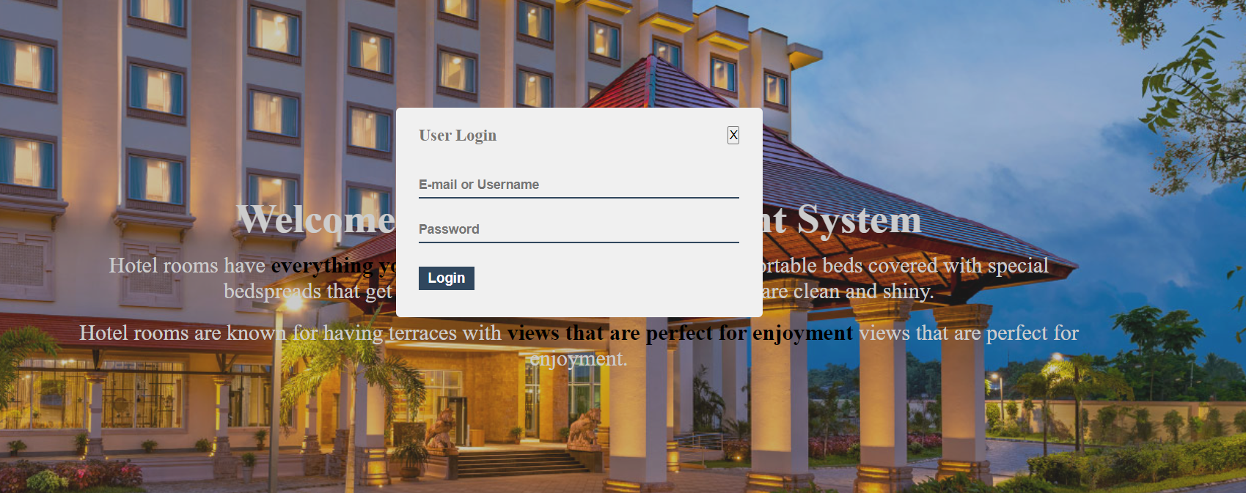

**Admin Login:**

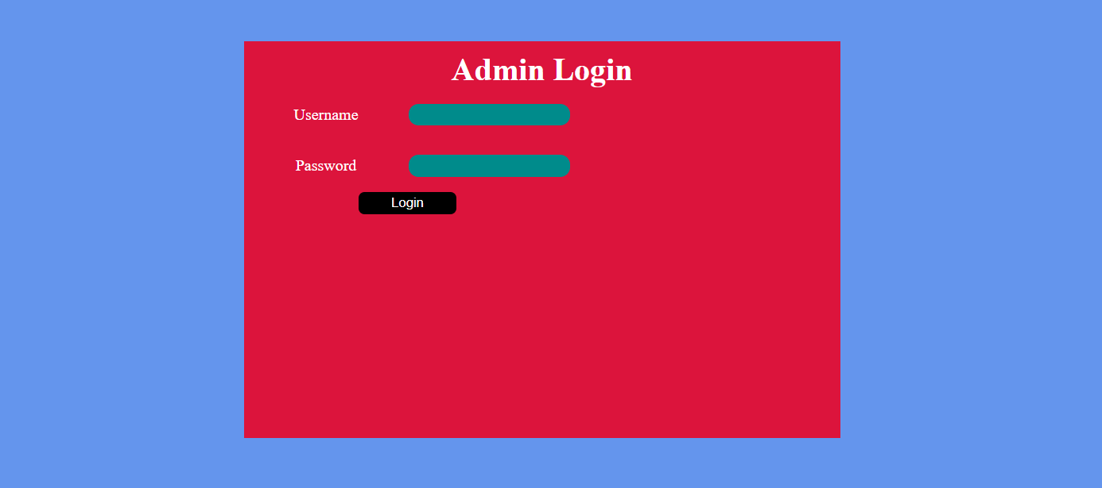

**Admin Page:**

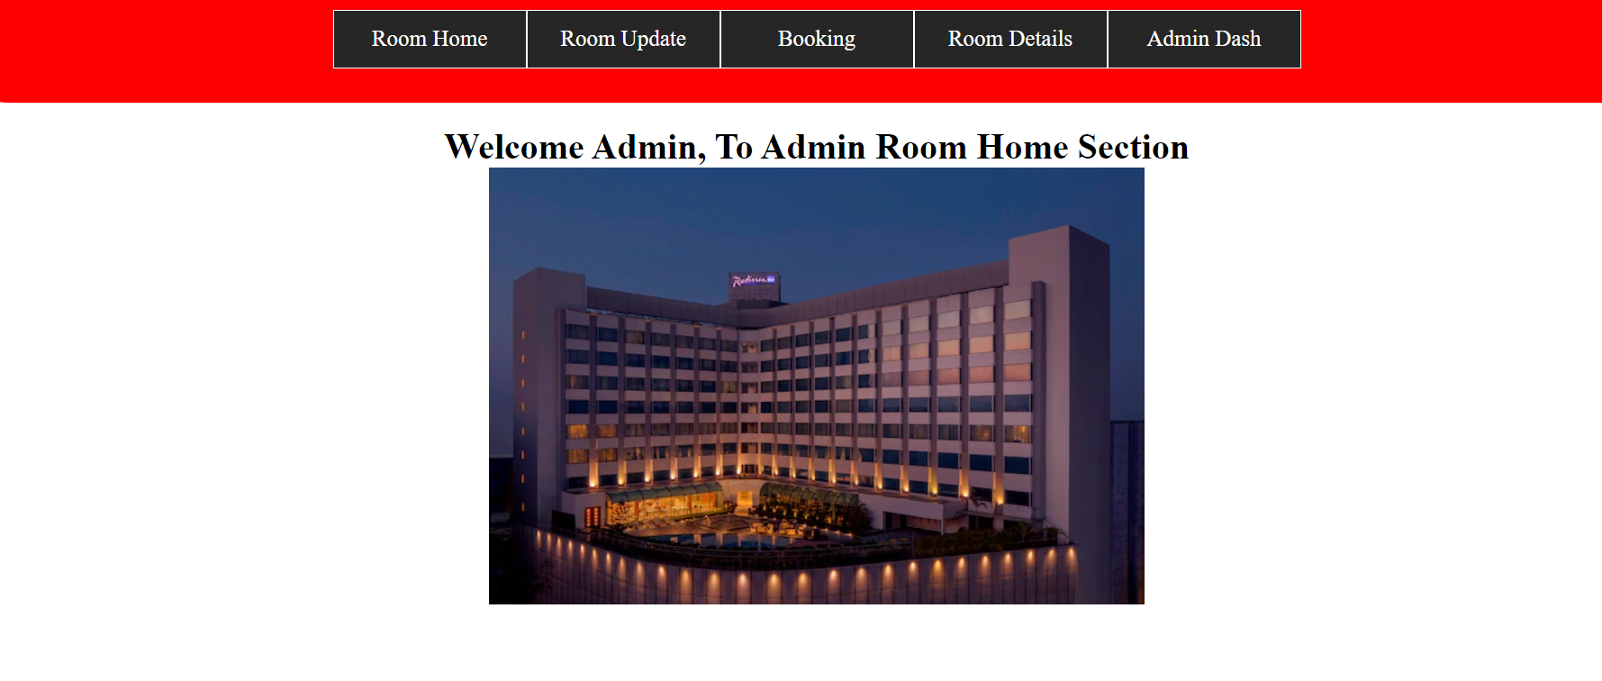

**CHAPTER 7**

**CONCLUSION AND FUTURE WORK**

**7.1 Conclusion:**

The conclusion of this project is A Hotel management system is a computerized management system. This system keeps the records of hardware assets besides software of this organization. This project has GUI based software that will help in storing, updating and retrieving the information. The project “Hotel Management System” is aimed to develop to maintain the day-to-day state of admission/Vacation of Residents, List of Workers , payment details etc. Main objective of this project is to provide solution for hotel to manage most there work using computerized process. This software application will help admin to handle customers information, room allocation details, etc. Detailed explanation about modules and design are provided in project documentation. The existing system is a manually maintained system. All the Hotel records are to be maintained for the details of each customers, Fee details, Room Allocation , Attendance etc. All these details are entered and retrieved manually, because of this there are many disadvantages like Time Consuming ,updating process, inaccuracy of data. For avoiding this we introduced or proposed a new system in proposed system the computerized version of the existing system. provides easy and quick access over the data.

7.2 Limitation:

Limitation of the present system:

i ) It requires an internet connection.

ii) It requires a large database

**7.3 FUTURE SCOPE OF THE PROJECT**

Overall, it can be summarized that the future scope of the project circles around maintaining information regarding: -

-We can give more advance software for Hotel management system including more facilities.

- We will host the platform on online servers to make it accessible worldwide.

- Create the master and slave database structure to reduce the overload of database queries

- Implement the backup mechanism for taking backup of codebase and database on regular basis on different servers

**CHAPTER 8**

**References:**

For designing, analysis and coding of the Hotel Management System Website following book, Websites were refered to:-

Book : Learning PHP, MySQL, JavaScript, CSS3 & HTML5

Websites:

i) [www.google.com](http://www.google.com)

ii) [www.w3schools.com](http://www.w3schools.com)

iii) [www.youtube.com](http://www.youtube.com)

iv) [www.javatpoint.com](http://www.javatpoint.com)

v) [www.stackoverflow.com](http://www.stackoverflow.com)

**Glossary**

**BVA: -**

In software testing, the Boundary Value Analysis (BVA) is a black box test design technique based on test cases. This technique is applied to see if there are any error at the boundary of the input domain. Thus, with this method, here is no need of looking for these errors at the center of this input.

**LOC: -**

The phrase “lines of code” (LOC) is a metric generally used to valuate a software program or codebase according to its size. It is a general identifier taken by adding up the number of lines of code used to write a program. LOC is used in various ways to assess a project, and here is a debate on how effective this measurement is.

**Unit Testing: -**

Unit testing is a level of software testing where individual units/ components of a software are tested. The purpose is to validate that each unit of the software performs as designed. A unit is the smallest test part of any software. It usually has one or a few inputs and usually a single output. In procedural programming, a unit may be an individual program, function, procedure, etc. In object-oriented programming (OOPS), the smallest unit is a method, which may belong to a base/ super class, abstract class or derived/ child class.

**Integration Testing: -**

Integration testing is a level of software testing where individual units are combined and tested as a group. The purpose of this level of testing is to expose faults in the interaction between integrated units. Test drivers and test stubs are used to assist in Integration Testing.

Beta Testing: - Integration testing is a level of software testing where individual units are combined and tested as a group. The purpose of this level of testing is to expose faults in the interaction between integrated units. Test drivers and test stubs are used to assist in Integration Testing.

**Agile Method: -**

sAgile is a methodology is a collection of software development methodology which works on an iterative and incremental method building the software from the very initiation of the project development instead of building all the software at once.